**Name-Ujjawal Mandhani**

**Batch-F6**

**Enroll No.-9918103237**

**ISL LAB TEST 1**

**Set-A**

**Question 1:**Write a program in C/C++ to implement simple mono-alphabetic cipher.

Key: "iwznflocysrdapvgqhbeuxmkjt"

Plain Text: "This is the lab test 1 for information security laboratory".

Also compute the time taken to perform encryption and decryption separately.

**#include <bits/stdc++.h>**

**#include <time.h>**

**using namespace std;**

**unordered_map<char, char> hashMap;**

**string encrypt(string msg)**

**{**

**string ciphertext;**

**for (int i = 0; i < msg.size(); i++)**

**{**

**ciphertext.push_back(hashMap[msg[i]]);**

**}**

**return ciphertext;**

**}**

**string decrypt(string msg)**

**{**

**string plaintext;**

**for (int i = 0; i < msg.size(); i++)**

**{**

**plaintext.push_back(hashMap[msg[i]]);**

**}**

**return plaintext;**

**}**

**void hashFn(string a, string b)**

**{**

**hashMap.clear();**

**for (int i = 0; i < a.size(); i++)**

**{**

**hashMap.insert(make_pair(a[i], b[i]));**

**}**

**}**

**int main()**

**{**

**clock_t start, end;**

**double cpu_time_used;**

**string alphabet = "abcdefghijklmnopqrstuvwxyz";**

**string substitution = "iwznflocysrdapvgqhbeuxmkjt";**

**string msg = "This is the lab test 1 for information security laboratory";**

**start = clock();**

**hashFn(alphabet, substitution);**

**string cipher = encrypt(msg);**

**cout << "Encrypted Cipher Text: " << cipher << endl;**

**hashFn(substitution, alphabet);**

**string plain = decrypt(cipher);**

**end = clock();**

**cpu_time_used = ((double)(end - start));**

**cout << "Decrypted Plain Text: " << plain << endl;**

**cout << "Time Taken in the Encrypt and Decrypt is: " << cpu_time_used << "milli seconds" << endl;**

**}**

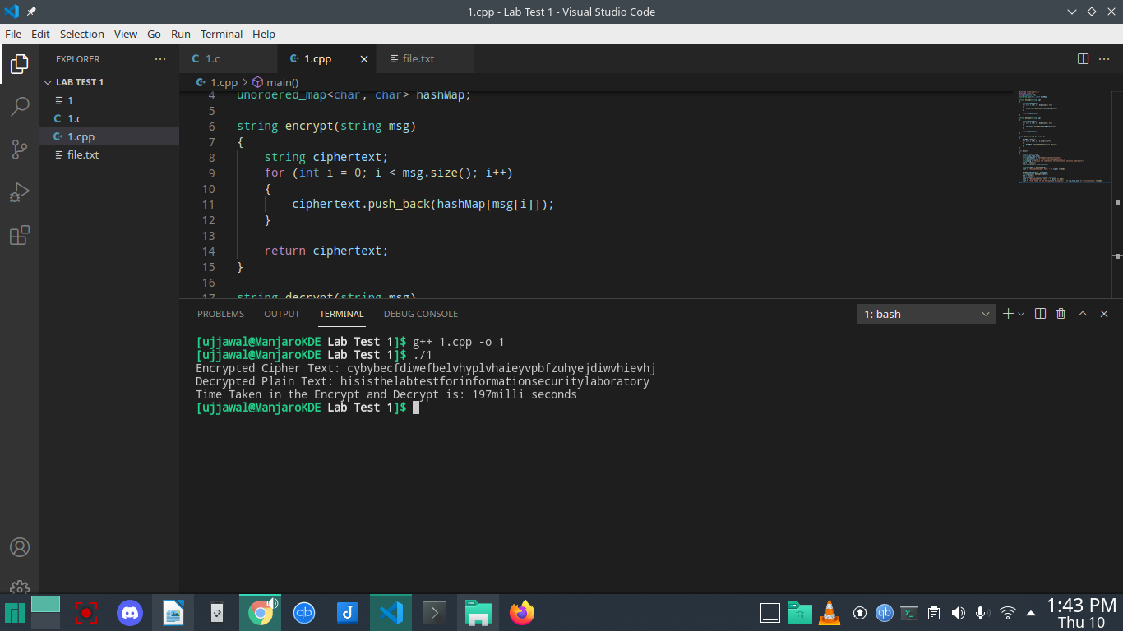

**Question 2:**Write a program to implement the following encryption scheme (One time pad)

**#include <stdio.h>**

**#include <string.h>**

**#include <ctype.h>**

**main()**

**{**

**//All the text which ever entered is converted to upper and without spaces**

**int i, j, len1, len2, numstr[100], numkey[100], numcipher[100];**

**char str[100], key[100], cipher[100];**

**printf("Enter a string text to encrypt\n");**

**gets(str);**

**for (i = 0, j = 0; i < strlen(str); i++)**

**{**

**if (str[i] != ' ')**

**{**

**str[j] = toupper(str[i]);**

**j++;**

**}**

**}**

**str[j] = '\0';**

**//obtaining numerical plain text ex A-0,B-1,C-2**

**for (i = 0; i < strlen(str); i++)**

**{**

**numstr[i] = str[i] - 'A';**

**}**

**printf("Enter key string of random text\n");**

**gets(key);**

**for (i = 0, j = 0; i < strlen(key); i++)**

**{**

**if (key[i] != ' ')**

**{**

**key[j] = toupper(key[i]);**

**j++;**

**}**

**}**

**key[j] = '\0';**

**//obtaining numerical one time pad(OTP) or key**

**for (i = 0; i < strlen(key); i++)**

**{**

**numkey[i] = key[i] - 'A';**

**}**

**for (i = 0; i < strlen(str); i++)**

**{**

**numcipher[i] = numstr[i] + numkey[i];**

**}**

**//To loop the number within 25 i.e if addition of numstr and numkey is 27 then numcipher should be 1**

**for (i = 0; i < strlen(str); i++)**

**{**

**if (numcipher[i] > 25)**

**{**

**numcipher[i] = numcipher[i] - 26;**

**}**

**}**

**printf("One Time Pad Cipher text is\n");**

**for (i = 0; i < strlen(str); i++)**

**{**

**printf("%c", (numcipher[i] + 'A'));**

**}**

**printf("\n");**

**}**

